**Docker Commands :**

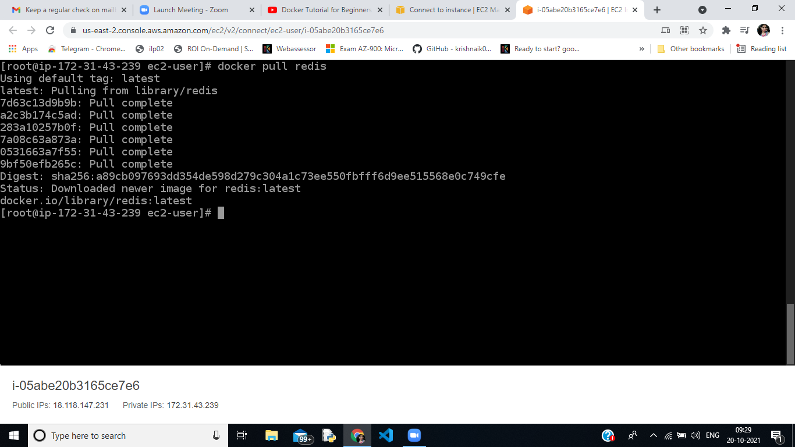

1. **Docker pull command is used to download docker image from public or private repository to local file. Redis image is downloaded**

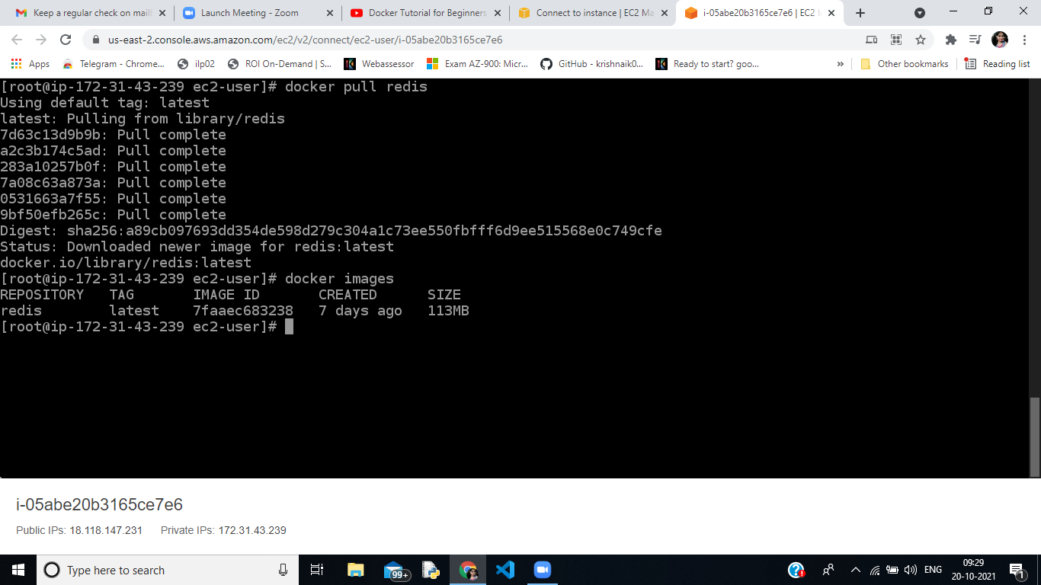

1. **Docker images - Used to list all images**

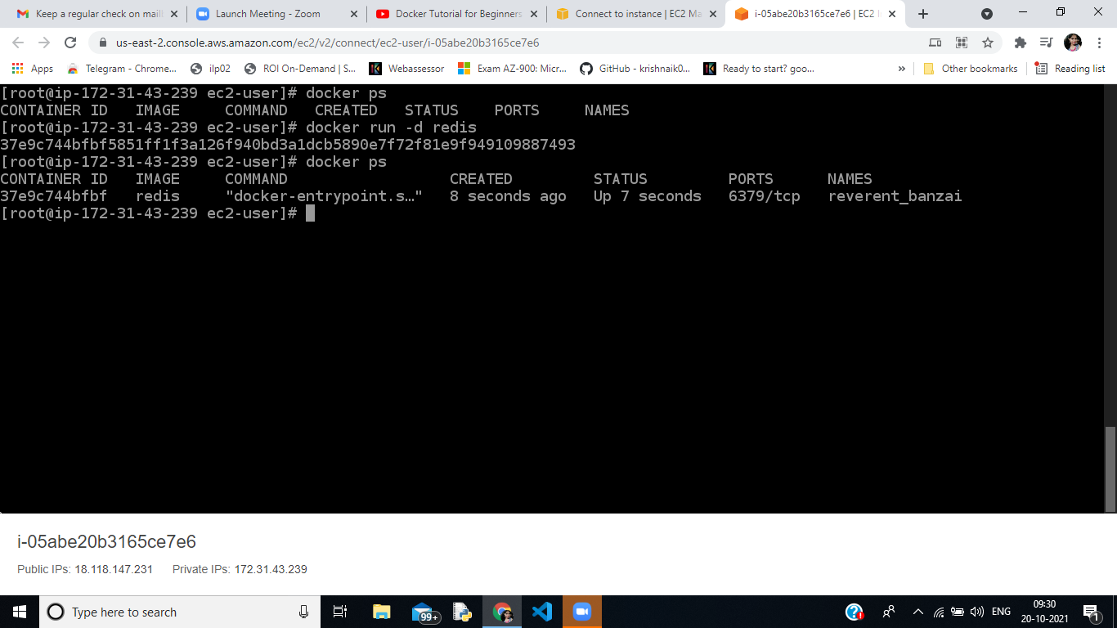

1. **Docker run command is used to run the container from the image . ‘-d’ is used for detached mode.**
2. **Docker ps is used to list all the containers running**

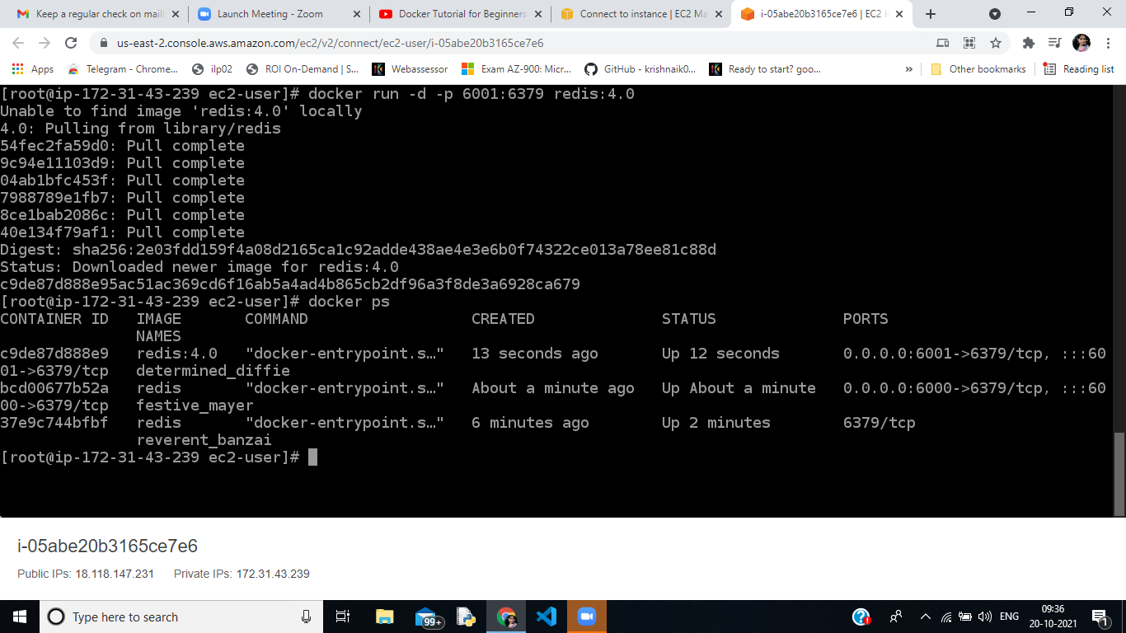

1. **Docker run is used for running container using the image , ‘-d’ detached mode , ‘p’ is used to publish a container port to the host port (8081:8080 where 8081 is host port and 8080 container port)**

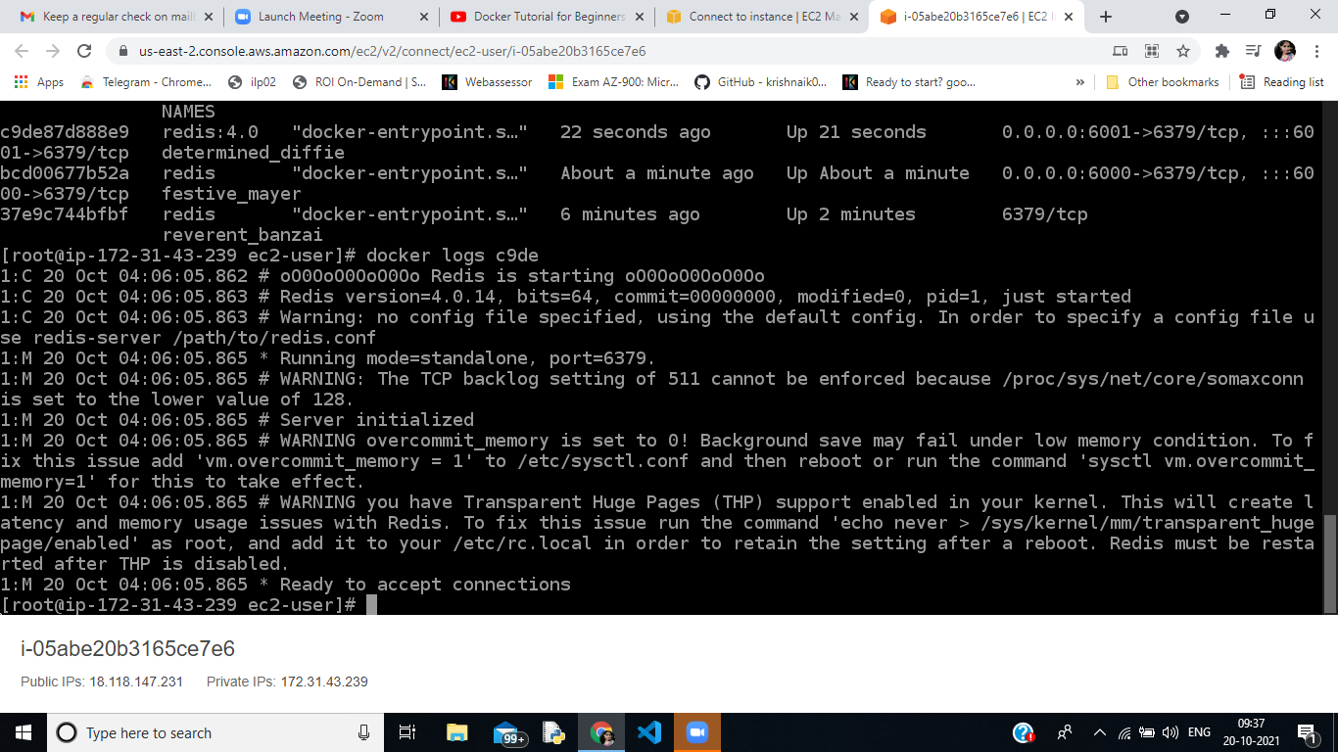

1. **Docker logs containerid → Used to check logs of a specific container**

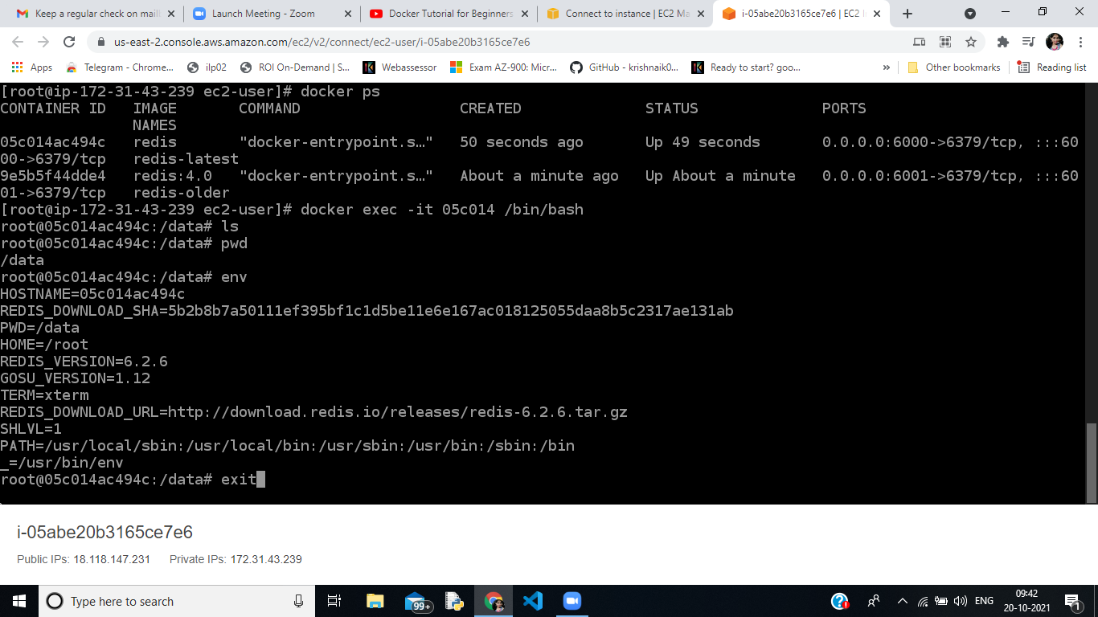

1. **Docker exec -it containerid /bin/bash is used to enter into the container, where -it is for interactive.**

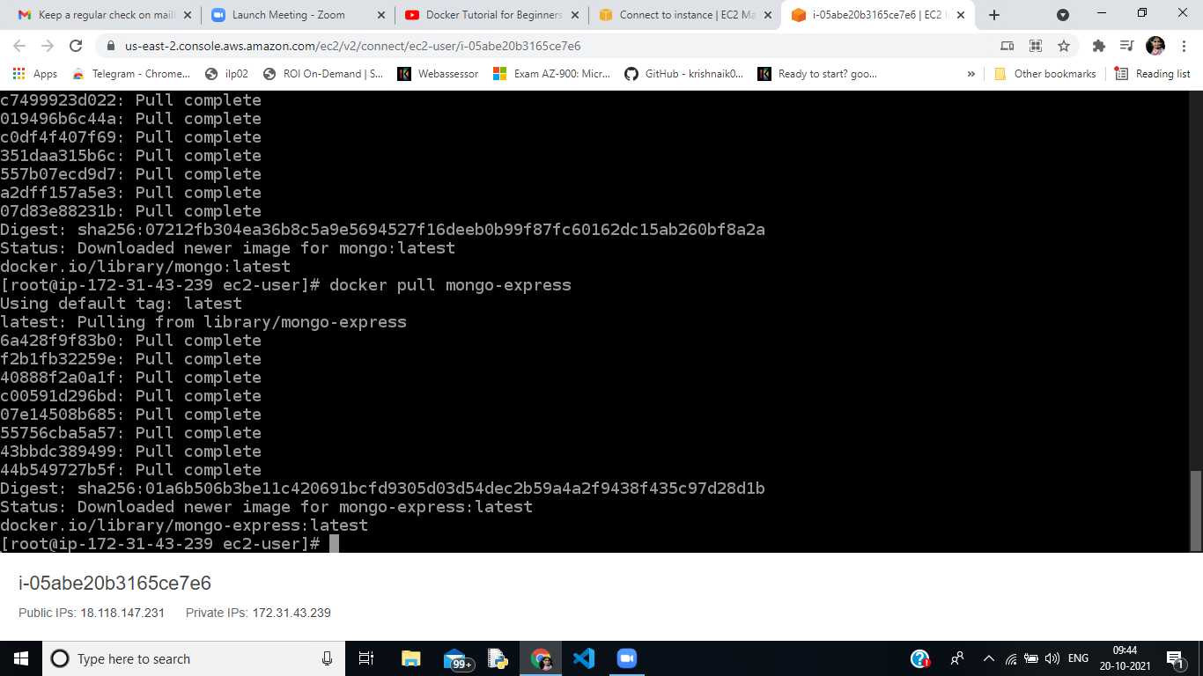

1. **Both the images mongo-express and mongob are running**

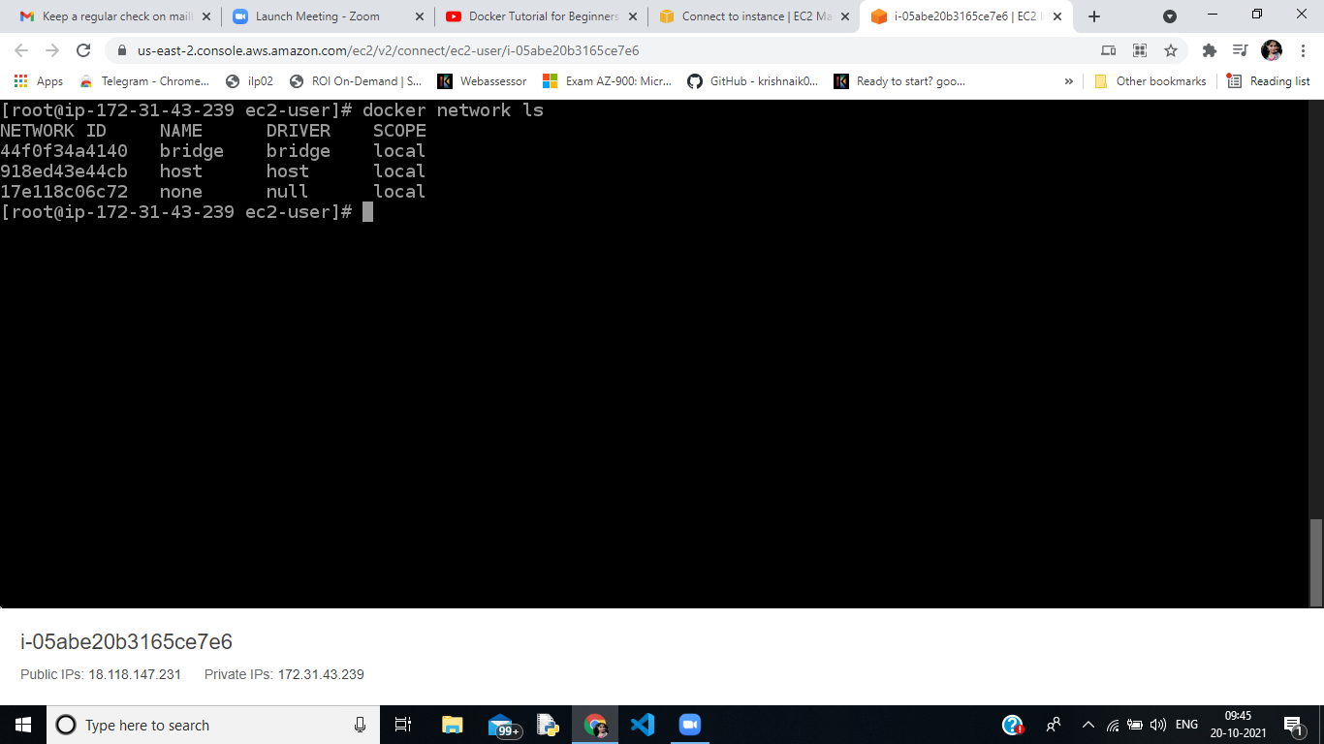

1. **Docker network ls is used to list the types of network**

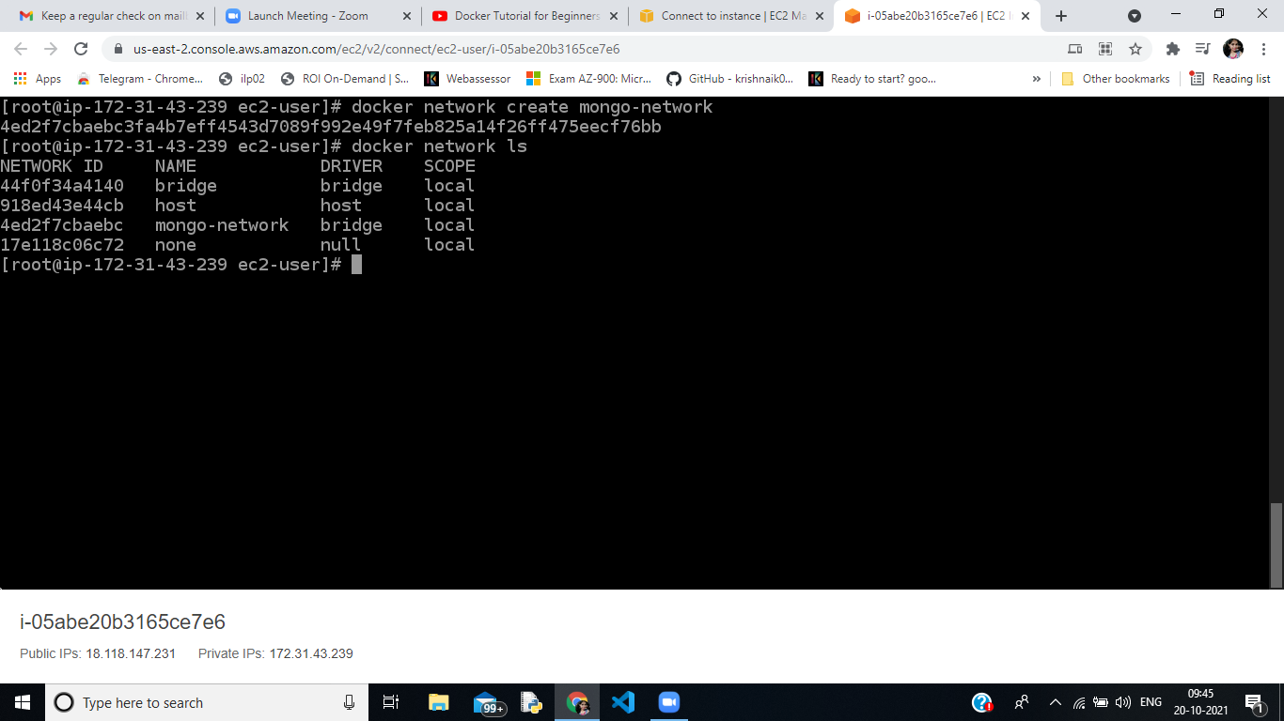

1. **Docker network create is used to create a new newtork.**

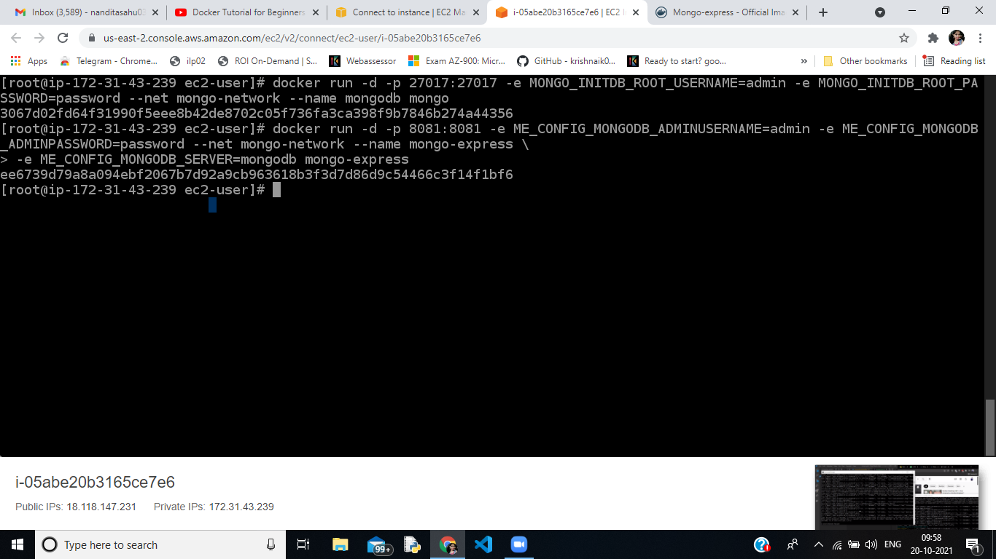

1. **Both the images are running, mongodb at 27017 and mongo-express at 8081.--name is used to provide a name to container, -e is for environment variable where username and password is added.**

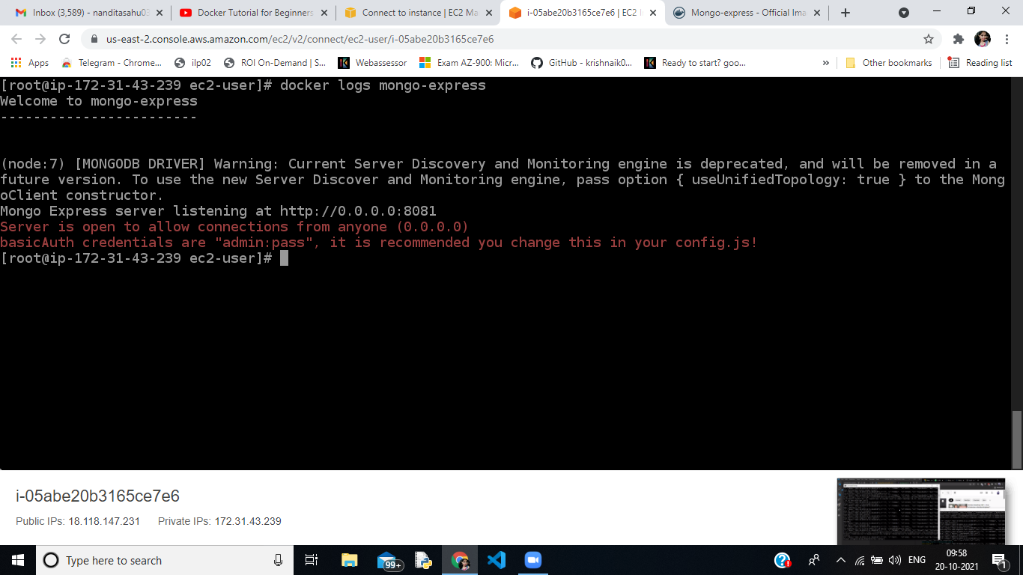

1. **Mongo-express is running**

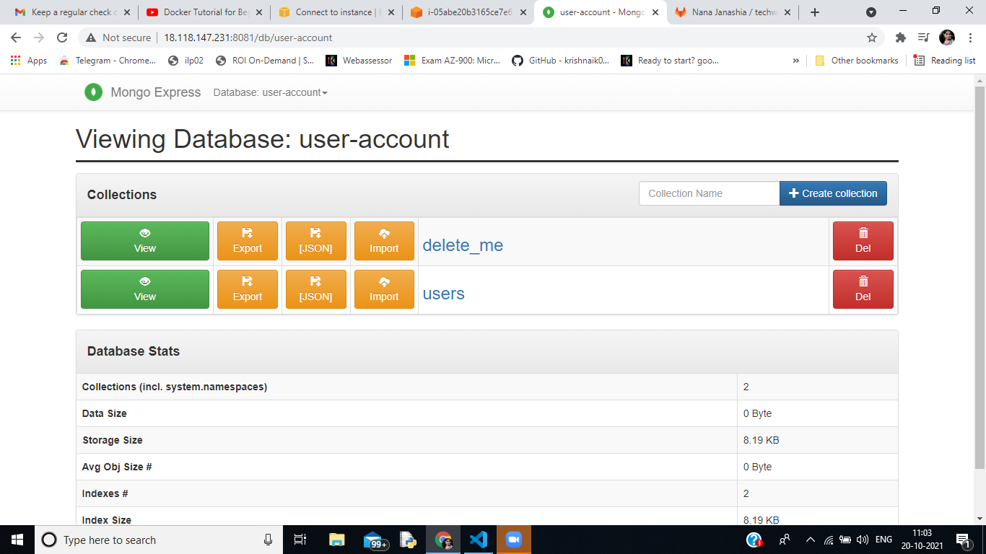

1. **Mongo-express container is up.**

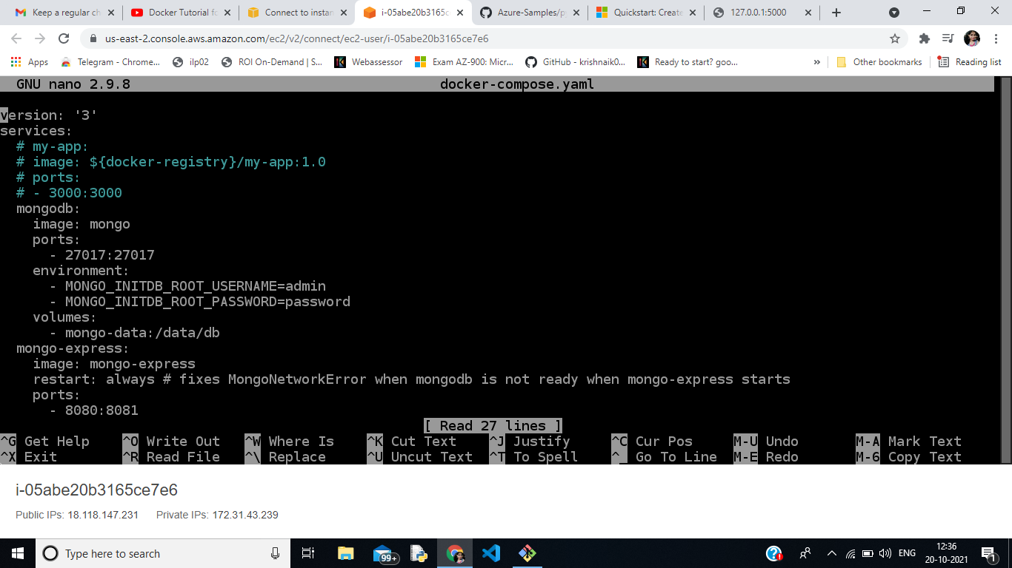

1. **Docker compose is easier way to run multiple docker images. It has .yaml fie .**

**It has 2 containers (mongodb,mongo-express).It by default creates a network so that containers can communicate.**

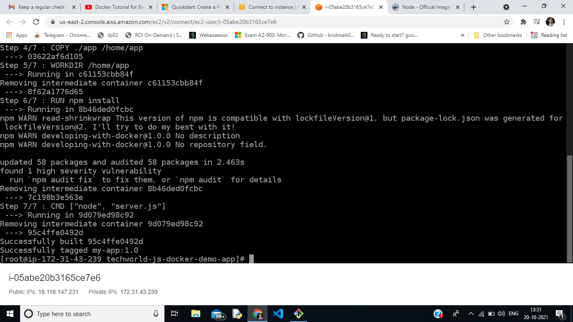

1. **Dockerfile is a file where we put all commands a user can could call on the command line to assemble an image.**

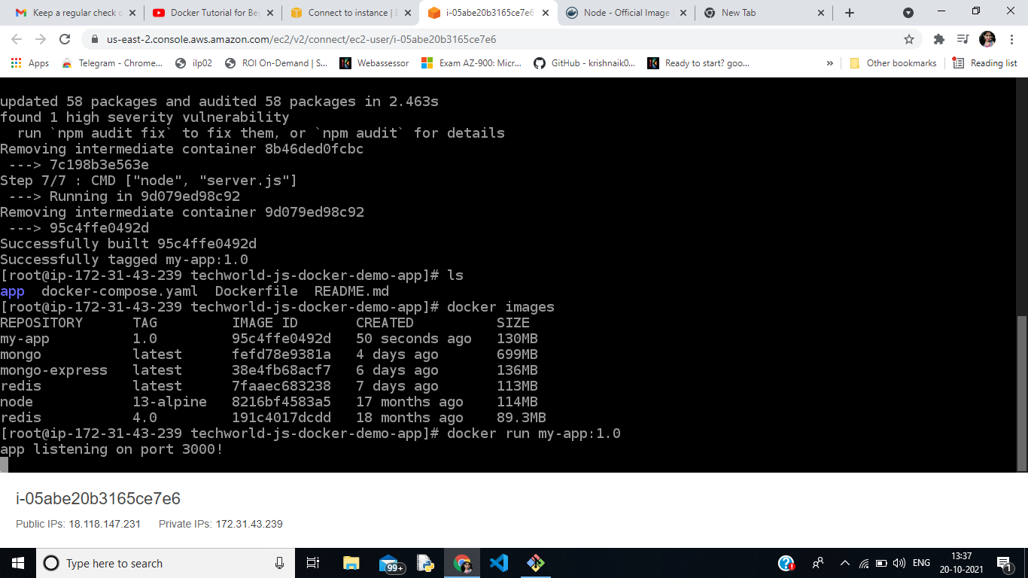

1. **After building the image through Dockerfile , docker run is used to run app**

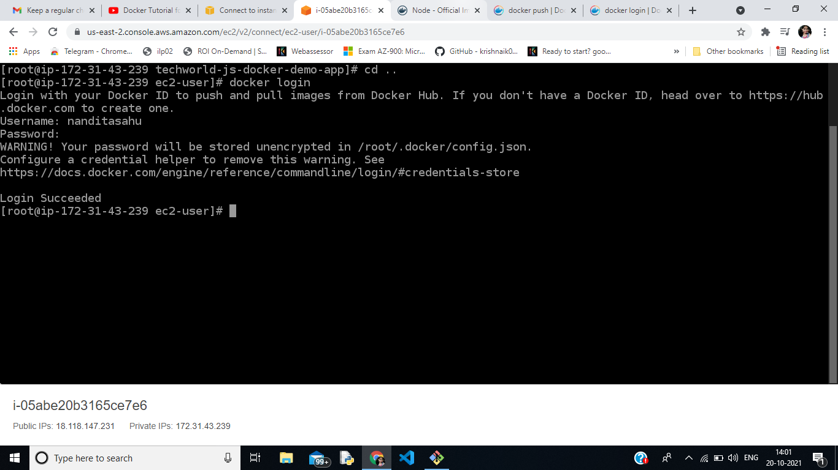

1. **Docker login → Used to login dockerhub(password, username)**

**Github Link :** [**https://github.com/Savegirlchild/docker-demo**](https://github.com/Savegirlchild/docker-demo)

**Dockerhub Link :** [**https://hub.docker.com/repository/docker/nanditasahu/dockerdemo**](https://hub.docker.com/repository/docker/nanditasahu/dockerdemo)